**Docker for Windows**

Docker Desktop for Windows is Docker designed to run on Windows 10. It is a native Windows application that provides an easy-to-use development environment for building, shipping, and running dockerized apps. Docker Desktop for Windows uses Windows-native Hyper-V virtualization and networking and is the fastest and most reliable way to develop Docker apps on Windows. Docker Desktop for Windows supports running both Linux and Windows Docker containers.

Instructions to install Docker -

1. Download Docker for Windows from <https://hub.docker.com/editions/community/docker-ce-desktop-windows>
2. Install Docker Desktop for Windows desktop app – Double-click Docker Desktop for Windows Installer.exe to run the installer.
3. Start Docker Desktop for Windows - Docker does not start automatically after installation. To start it, search for Docker, select Docker Desktop for Windows in the search results, and click it (or hit Enter).

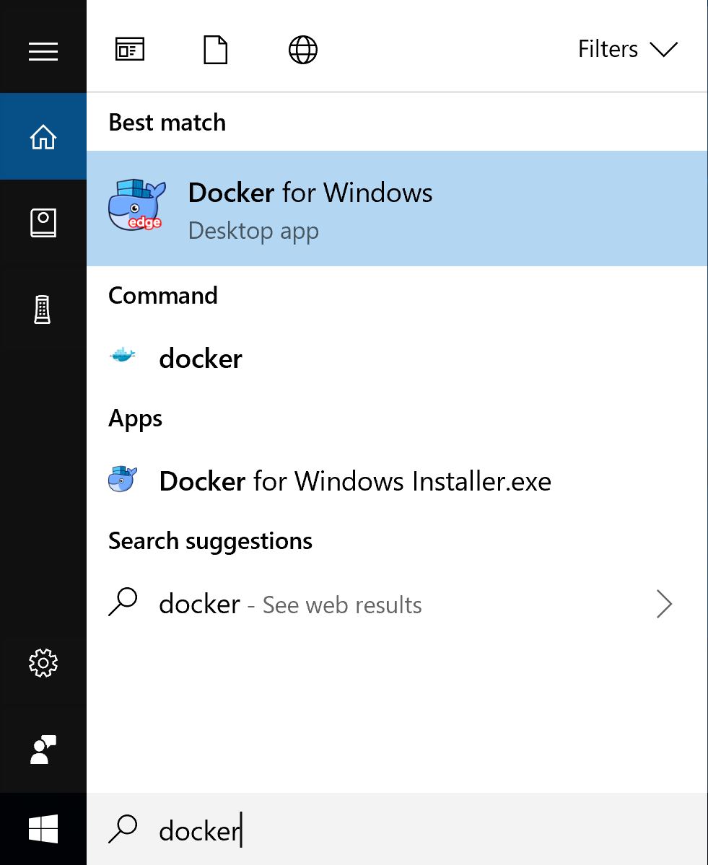

1. Login to Docker Hub with your credentials

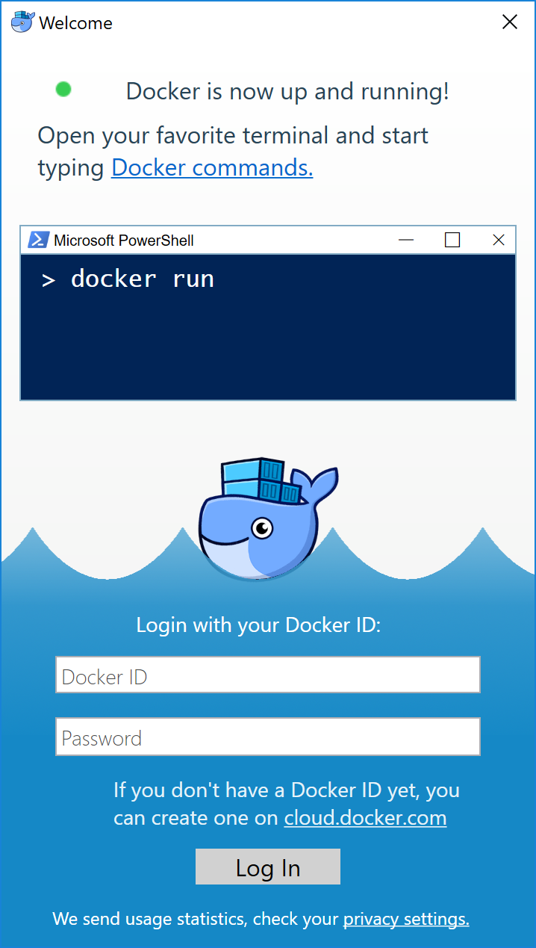

1. When the whale in the status bar stays steady, Docker is up-and-running, and accessible from any terminal window.



Congratulations! You are up and running with Docker Desktop for Windows.